Incredible Rod Stewart Tribute Act

There are other Rod Stewart tribute acts, but none is as convincing as Garry Pease
Garry Pease not only looks like Rod Stewart, he sounds like him too!
In an all-action, non-stop tribute show, Garry performs all of the favorites from Rod Stewart’s vast portfolio of songs – everything from the early Faces days through to the Old American Songbook.
Last year, The Rod Stewart Experience had Sincere Support guests singing along and dancing on their feet as they experience this authentic tribute act.
The show had everything you would expect from a real concert – superb showmanship, audience participation and superb songs belted out in exactly the same style as Rod Stewart – in fact, it’s exactly what a Rod Stewart act should be.
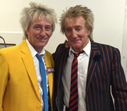
You could hardly tell the difference between Garry and Rod Stewart – and once the party got going, nobody cared; they were all having such a great time.
This unique tribute act, sound-alike and look-alike and is the nearest thing to having your own Rod Stewart concert with The Rod Stewart Experience.
Come and join us on SATURDAY 30TH APRIL 2016 at THE GARISSON, PENISTONE ROAD, SHEFFIELD S6 2GB and see for yourself this amazing show, Sincere Supports’ personalised Rod Stewart Experience – tonight, he’s yours!
Tickets priced at £10.00 and available from Bev Lister 07855 770782 or Peter Taylor 07774 700373

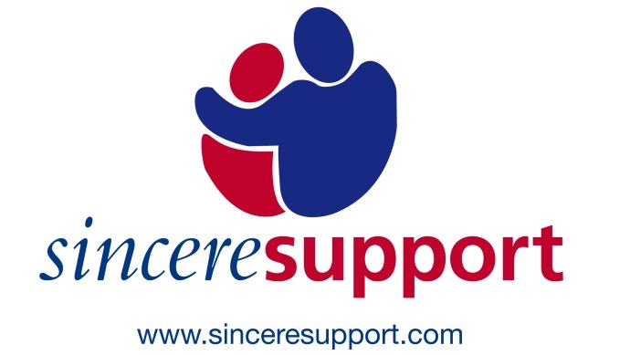
Registered charity number 1100487

